**Lab Task 8 (1,2) DSA**

**Explanation:1**

**Node Structure**: Defines a linked list node with data and next pointer.

**Insertion Function:** Adds elements at the end of the list.

**Display Function:** Prints the linked list.

**Merge Function**: Recursively merges two sorted linked lists.

**Main Function**

**OUTPUT:**

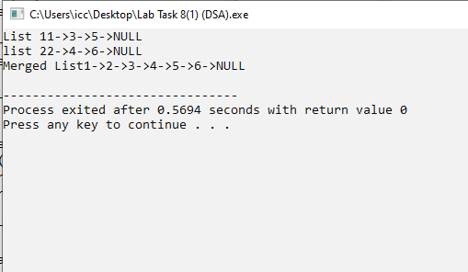

**Explanation 2:**

* Doubly Linked List with functions to insert nodes.
* display the list, and merge two lists.
* The insert function adds nodes at the end, display prints the list, and mergeLists links two lists together.
* In main, two linked lists are created, merged, and displayed.

**OutPut:**

